Name-Nimesh Shahi (4358)

Name- Devansh Vishwakarma (4362)

Class/Div- TYIT/A

Topic- Analyzing YouTube Channel

Subject- Business Intelligence

**Case Study: Analyzing YouTube Channel**

**Background**:

In recent years, the Indian digital entertainment landscape has seen a surge in popularity, with YouTube emerging as a prominent platform for content consumption. With over a billion users, YouTube offers Indian content creators an extensive reach and the opportunity to engage with a diverse audience. From comedy sketches to educational tutorials and lifestyle vlogs, Indian YouTube channels cater to a wide range of interests and preferences. Understanding audience engagement metrics such as likes, dislikes, and views is crucial for content creators to assess their content's performance and adapt their strategies to meet audience expectations. This case study aims to analyze the engagement metrics of a popular Indian YouTube channel over a specified period to derive insights into audience preferences and content effectiveness.

**Objective:**

The objective of this case study is to delve into the engagement metrics of a prominent Indian YouTube channel, focusing on the dynamics between likes, dislikes, and views. Over a designated time frame, we aim to dissect audience behavior patterns and discern content preferences across different genres, including comedy, education, and lifestyle. By meticulously analyzing these metrics, we seek to unearth valuable insights into the factors influencing viewer engagement, such as content quality, relevance, and presentation style. Additionally, we aim to explore the correlation between audience interaction metrics like comments and shares and their impact on overall engagement levels. Ultimately, our goal is to provide actionable recommendations to the channel creators for optimizing content strategy, enhancing audience engagement, and fostering sustained growth and success within the competitive Indian YouTube landscape.

**Data Collection:**

Data was collected for a period of One Year, spanning from 2023 to 2024. The channel's videos were categorized into different genres to understand audience behavior across various content types.

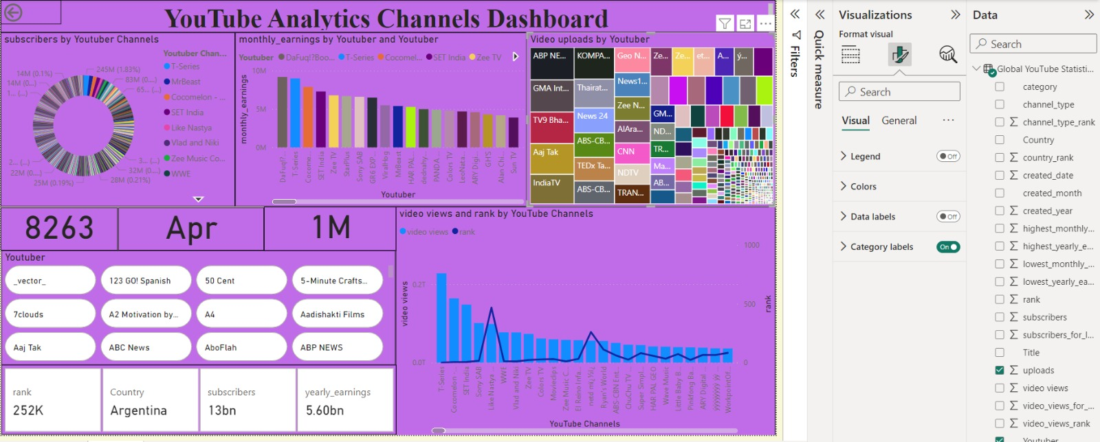

**Findings:**

**1. Overall Engagement Trends:**

- Total Views: The channel experienced a steady increase in total views over the six-month period, indicating sustained viewer interest.

- Likes vs. Dislikes: The ratio of likes to dislikes varied across videos, with some videos receiving overwhelmingly positive feedback, while others had a more mixed reception.

**2. Genre Analysis:**

- Comedy Sketches: Videos in this genre consistently garnered high views and a high ratio of likes to dislikes, suggesting strong audience engagement and appreciation for comedic content.

- Educational Videos: While these videos received fewer views compared to comedy sketches, they often had a higher ratio of likes to dislikes, indicating a dedicated audience interested in educational content.

- Lifestyle Vlogs: Views for lifestyle vlogs fluctuated, with some videos receiving high engagement while others had a lower response. The ratio of likes to dislikes varied widely depending on the topic and presentation style.

**3. Audience Interaction:**

- Comments: The channel had an active comment section, with viewers expressing their opinions, feedback, and suggestions. Engagement through comments was particularly high for videos discussing controversial topics or current events.

- Shares: Certain videos were shared widely across social media platforms, contributing to increased views and exposure for the channel.

**Insights:**

**1. Content Strategy:**

- The channel should continue to produce a mix of content across different genres, capitalizing on the popularity of comedy sketches while also catering to niche audiences interested in educational and lifestyle content.

- Analyzing the performance of individual videos can help in identifying successful content formats and refining future production strategies.

**2. Audience Engagement:**

- Engaging with the audience through comments and incorporating viewer feedback can foster a sense of community and loyalty among subscribers.

- Understanding audience preferences and tailoring content accordingly can lead to higher engagement and viewer satisfaction.

**3. Quality vs. Quantity:**

- While it's important to maintain a consistent upload schedule, prioritizing quality over quantity can lead to higher viewer retention and engagement.

- Investing in production value, storytelling, and creative execution can set the channel apart and attract a larger audience.

**Conclusion:**

Through comprehensive analysis of engagement metrics like likes, dislikes, and views on the Indian YouTube channel, we have gained valuable insights into audience preferences and content performance. The examination of various content genres highlighted the popularity of comedy videos, the engagement of educational content, and the variability in lifestyle vlogs. Audience interaction metrics, such as comments and shares, further underscored the importance of fostering community engagement and addressing viewer feedback. By leveraging these insights, the channel can refine its content strategy, prioritize quality over quantity, and tailor content to better resonate with its audience. Implementing these recommendations can lead to enhanced audience satisfaction, increased viewer retention, and sustained channel growth within the competitive Indian YouTube landscape. Ultimately, the channel's success hinges on its ability to adapt to evolving viewer preferences and deliver compelling content that resonates with its audience.